Frontend Service URL:
http://ab291f3c783d7442f90800e3755330d7-312351645.us-east-1.elb.amazonaws.com
Backend /movies URL:
http://a0889f6bde6994db78e34e34470bd323-1960819390.us-east-1.elb.amazonaws.com/movies

Screenshot — Kubernetes

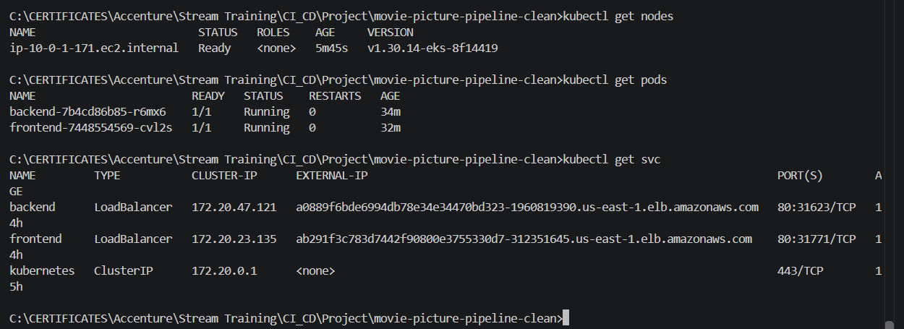

Screenshot — Backend movie list
